|  |  |
| --- | --- |
| C:\Users\Feroz\Pictures\logo2.jpg  SNAKE & LADDER  WINDOWS 8 APP | Abstract  A Windows 8.1 App, build using XAML and C# programming language. |

**PROJECT ON**

SNAKE & LADDER

DEVLOPED BY

NAME: Sarojee Chetri

http://cloudscape.cloudcampus.com/Cloudscape/Uploads/BestPractices/Sample%20Case%20Study/05_OOPS_Project_SG_files/image027.jpg

**SNAKE & LADDER**

Batch Code :B160226

Name of the Developer :Sarojee Chetri

Date of Submission :14th Feb 2017

http://cloudscape.cloudcampus.com/Cloudscape/Uploads/BestPractices/Sample%20Case%20Study/05_OOPS_Project_SG_files/image028.jpg

**CERTIFICATE**

This is to certify that this report titled Snake & ladder embodies the original work done by Sarojee Chetri in partial fulfillment of the course requirements at NIIT.

http://cloudscape.cloudcampus.com/Cloudscape/Uploads/BestPractices/Sample%20Case%20Study/05_OOPS_Project_SG_files/image028.jpg

**Acknowledgement**

*We have benefited a lot from the feedback and suggestions given to us by Mr. Priyanjit Poddar and other faculty members.*

**SYSTEM ANALYSIS**

**System Summary**

KidzFun Inc. is a company that specializes in developing computer games that run on Windows 8. You work a game app developer at KidzFun Inc. You are assigned the task of developing a game named SnakeNLadder.

There are two players in the game, one has a green disc and the other has a blue disc. The UI consists of a board containing 100 squares. These squares are numbered from 1 to 100 and are arranged in a 10x10 grid, as shown in the following figure.

The players take turns in rolling a dice. The player moves the disc towards hundredth square starting from the first square based on the number that appears on the dice. This means that the disc takes as many steps to move forward on the game board as the number that appears on the dice. This process continues until either of the players is able to reach the hundredth square. The player who reaches the hundredth square first is the winner.

Being an app developer, you need to ensure that the app provides the following functionalities:

■  It is a game that involves two players.

■  The game board contains 100 squares, 10 snakes, and 10 ladders.

■  The squares are arranged in a grid of 10 rows and 10 columns.

■  The player, Player 1, has a green disc, and the player, Player 2, has a blue disc.

■  Initially, both the discs are placed on the first square. The first square is numbered 1 and is positioned at the bottom left corner.

■  The players can interact with the game by using a mouse or finger touch.

■  Player 1 has the first turn to roll the dice.

■  To roll the dice, a player needs to click a button, which has the caption, **Roll Dice**. When a player clicks the **Roll Dice** button, the images representing the values 1 to 6 are randomized on the screen.

■  Based on the number that appears on the dice image, the disc of the current player automatically moves forward. The number of steps that the disc takes to move forward, should be equal to the number that appears on the dice.

■  If the disc lands at the mouth of a snake, the disc is dropped to the square at which the snake’s tail ends.

■  If the disc lands at the base of a ladder, the disc automatically climbs to the square at which the ladder ends.

■  If Player 1 is able to reach the hundredth square first, Player 1 wins the game.

■  If Player 2 is able to reach the hundredth square first, Player 2 wins the game.

■  Once the game gets over, the player should be given the option to start a new game.

■  The game page contains a **Help** button on the UI that the player can click to view the rules of the game.

■  The player should have an option to check the scores by clicking a button on the UI. Clicking on this button should display the scoreboard in the following format:

Games won by the Player 1: ########

Games won by the Player 2: ########

Number of times the game was cancelled: ########

■  The app allows the users to continue the game from where they left.

■  The app allows the user to cancel the current game.

■  The app must provide a fast and fluid experience by using page transitions.

■  The app must be resolution independent.

■  The controls added in the app should have a consistent look and feel.

**INTERFACE DESIGN of Snake & Ladder**

*Main Menu*

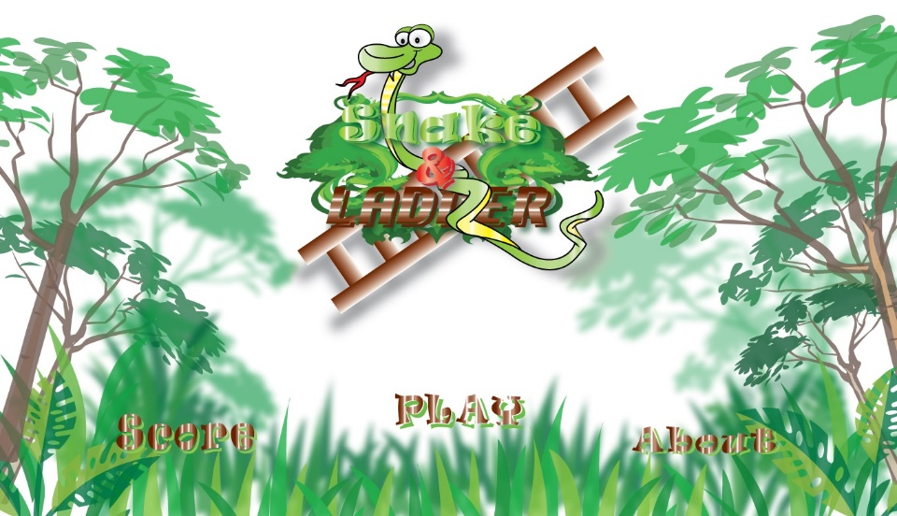

*Game page*

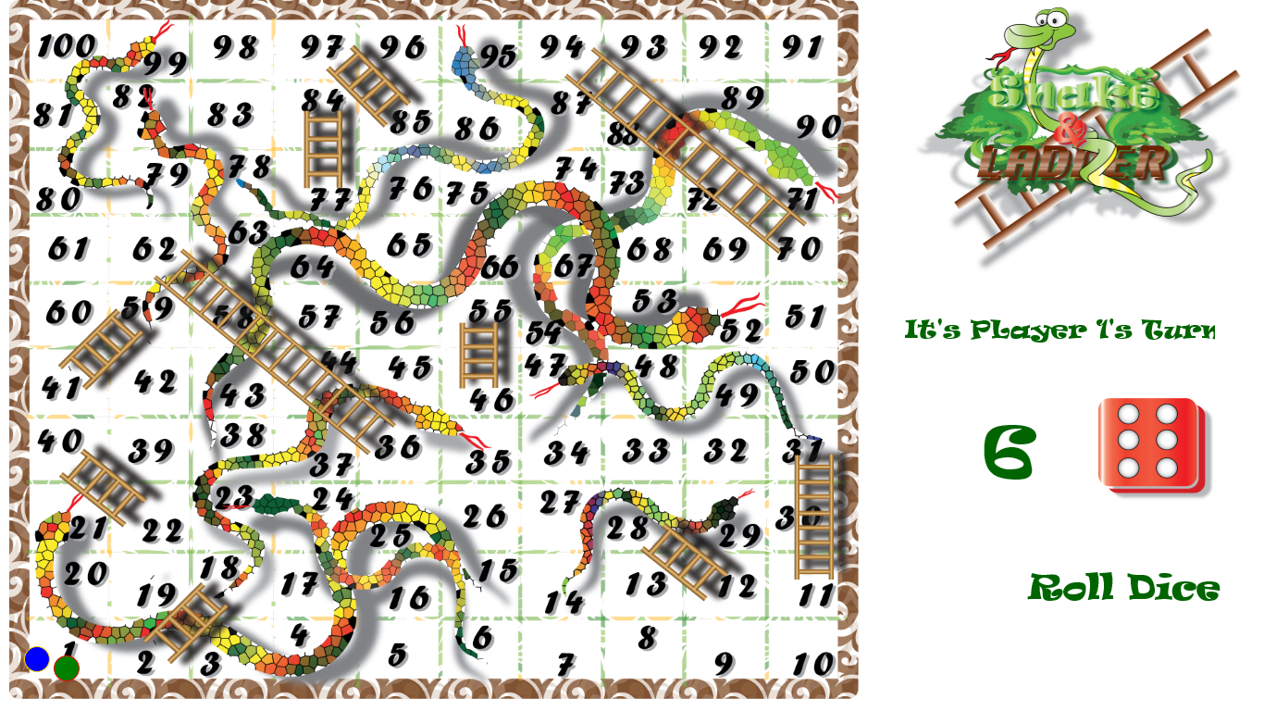

**Various Methods**

|  |  |
| --- | --- |
| ***Methods of the Snake & Ladder Game*** | |
| GlobalClass | *This class Give access to public static variable.* |
| MainUIpage.xaml | *This Page has the Menu UI of the game* |
| MainPage.xaml | *This page has the game board UI and logic of the game* |
| Option.xaml | *This page can be accessed by using windows charm bar the click on option* |
| diceMethod() | *This method will give random dice number* |
| SnakeLadderPosiotion () | *This method will check if the player is bitten by snake or on the ladder* |
| Winner() | *This method will check if the player is won* |
| ContinueG () | *This method will save the game if the game is being canceled* |

**CONFIGURATION**

**Hardware            :**Intel i5 4200M @ 2.50GHZ

                                 4 GB RAM

                                500 GB 5400 RPM Hard Drive

                                10/100 NIC

                                 Touch Pad

                                 Keyboard

                                 15.6” Color Lcd

**Operating system**: Windows 8.1 pro

**Software**       : Visual Studio 2013 Professional

**Acknowledgement**

We take this opportunity to express our profound gratitude and deep regards to our faculty Miss V.Sweta and Mr.Priyanjit Poddar for his exemplary guidance, monitoring and constant encouragement throughout the project of the shuffle. The blessing, help and guidance given by her time to time shall carry us a long way in the journey of life. Furthermore we would also like to acknowledge with much appreciation the guidance given by other supervisor as well as the panels especially in our project presentation that has improved our presentation skills thanks to their advices.

-Sarojee Chetri

**Conclusion**

Snakes and ladders is an ancient game based on life. It is a game for children as well as adult, anyone can enjoy it. However there is a fair bit of maths in the game. Probability, random walks and expectation values.

There were many limitations because we have to build a console application but we really learned many things, if you have any question please feel free to ask me now.

**Bibliography**

We have taken reference from the following sites that are:

* Microsoft developer Network (MSDN )
* Microsoft Virtual Academy
* Google search engine